TASK 9 — Python Code Generation using Structured Prompting
AIM
To design a structured prompt that instructs an LLM to generate a Python program for a specified computational problem and validate the generated code using test cases.
PROCEDURE
1. Identify the computational problem to be solved.
2. Define the role of the LLM as an expert Python programmer.
3. Specify the input, requirements, constraints, and expected output.
4. Construct a structured prompt containing all required information.
5. Submit the prompt to the LLM and obtain the generated Python program.
6. Run and validate the generated program using predefined test cases.
7. Compare the actual results with the expected results and record the outcome.
PROMPT
ROLE:
You are an expert Python programmer.
TASK:
Generate a Python program to check whether a given integer is a prime number.
INPUT:
One integer n.
REQUIREMENTS:
1. Accept an integer from the user.
2. Check whether the number is prime.
3. A prime number must be greater than 1 and have exactly two factors.
4. Display whether the number is prime or not.
5. Use efficient logic.
CONSTRAINTS:
- Use Python 3.
- Use clear variable names.
- Include comments for important steps.
- Handle numbers less than or equal to 1 correctly.
OUTPUT FORMAT:
Return Python source code, a brief explanation, and three test cases.
VALIDATION:
Test with n = 7, n = 10, and n = 1.

INPUT
Computational problem: Determine whether the user-provided integer is a prime number.
Test values: 7, 10, 1.

OUTPUT
OUTPUT — PLACE GENERATED OUTPUT IMAGE HERE
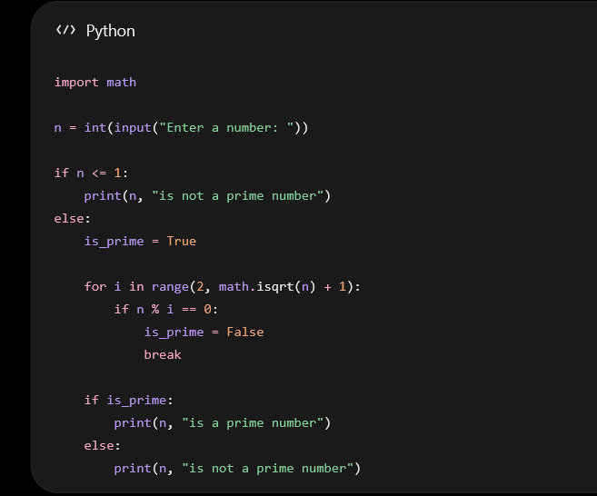

RESULT
The structured prompt successfully instructs the LLM to generate a Python prime-number program and provides clear requirements for validating the generated code.

